Rude aka Clark Ross Rude Cemetery

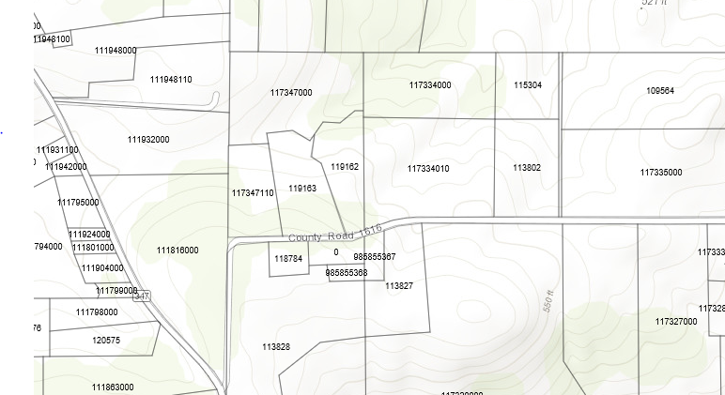

Across from 1404 CR 1616, Jacksonville TX 75766

Next to 1519 CR 1616, Jacksonville, TX 75766